**Project Name:**

Know More about Figure Skating

**Description:**

Watching figure skating is one of my favorite hobbies, and I plan to make a project that is related to figure skating. I hope it can get the information I need from Wikipedia, print it the form of dictionary or list, search for the keyword(for example, the name of an athlete) I entered on Wikipedia and Google, and get the video title and the URL of the video from Youtube.

There are few ice rinks in Taiwan and not many people can ice-skate, so figure skating is not a well-known sport in Taiwan, and we seldom see the news of it. What’s more, there are various competitions each year but seldom can we see the competitions on television.

There are lots of outstanding athletes who are well-known around the world and make wonderful programs or performances. I hope people in Taiwan can know more about figure skating and love it more.

**Project Planning:**

I’ll crawl the website by using Beautiful Soup, and use Wikipedia and Youtube API to get the data. Users can get the data in the form of dictionaries or lists from Wikipedia, and get the search results of Google and Youtube.

First, I’ll browse the website of the “2019–20 figure skating season” on Wikipedia, use Beautiful Soup for crawling, and get the information I want. For example, recent competitions, the name of athletes, International medalists, the best scores, ranking, and so on. I’ll put those data in dictionaries or lists and print them. Users can get the information of the previous season if they want. Then, crawl the website again, deal with those data, and print it out.

Second, users can enter something and use the Wikipedia API to search for a certain keyword (for example, an athlete or a competition). Then, use JSON to get the data from the website. For example, the short description of the competition, the medalists of the competition in the recent season. Then, put them in dictionaries or lists and print them. If users want to get the information of the previous season, then use API to get the data on that page, deal with it, and print it.

Third, search on Google. Search for the keyword which is entered by the user, and crawl the page and print the title list of the searching result on the first three pages of Google. Users can know what those athletes happened recently and what competition has finished by those titles.

Last, use Youtube API to search for the certain keyword entered by the user, and then get the video title names and the URL of those videos. Users can easily get the video titles and the URL of them. Users can also decide the number of results they want to get.

**Timeline:** 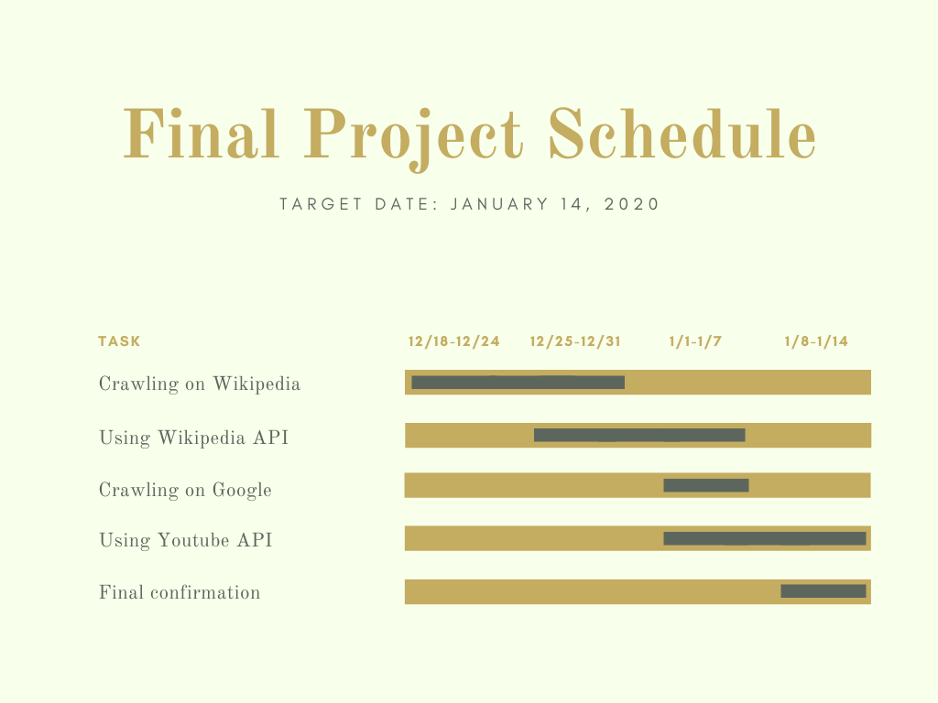

**Update1**

1.What I have done.

Crawling wiki(the figure skate page of this season), get the data, and make a dictionary of the competitions and the dates

Use youtube API to get the title name of the videos.

Use wiki API the get the URL of the search result.

2.Any changes on the final project plan, and why

Check if the page really exists.

Use try-except to avoid errors.

3.Timeline for the rest

this week: continue to crawl on the wiki to get more data, crawl google search

next week: combine all code

last week: final check

**Update 2**

1. I change the part of crawling google because it is not convenient. Instead, I use the Custom Search API to do it. I can easily get the website title and the URL of it.

2. About crawling the page “2019–20 figure skating season” on Wikipedia, I get the top 20 athletes(men and ladies) name list of the season's best total score and make two lists to store them. I also get the name and date of each competition and make a dictionary to store them. For the previous season, I also get the top 20 name list of the season's best total score.

3. You can use the name in the lists above to be the keyword of searching. You can also choose to enter something by yourself to search for.

4. You can use the Wikipedia API to get the ID of the page, so you can get the URL of that page. You can also get the introduction of that page by using the Wikipedia API.

5. You can enter a number to decide how many results you want to get from Youtube and Google Search.

6. The program will continue asking you to make some search. If you don’t want to search anymore, you can enter ‘EXIT’ to end the program.

**Run**

Needed libraries:

import urllib.request, urllib.parse, urllib.error

import ssl

import re

import requests

from bs4 import BeautifulSoup

from googleapiclient.discovery import build

How to run the project:

First, you’ll see some data(crawling Wikipedia page of this figure skating season) of the top 20 name list of the season's best total score(men and ladies), the competitions, and the dates.

Second, you’ll be asked to enter the name of the competition to know the date. Please notice the uppercase and lowercase. You can enter 'EXIT' to stop searching competitions and to see other data.

Third, it’ll ask you if you want to know more about the previous season? (Y/N) You can enter ‘Y’ to get the data of the previous season or enter ‘N’ to skip it. If you enter something other than ‘Y’ or ‘N’, it’ll show ‘Wrong input’.

Fourth, it’ll tell you to enter 'LIST' to use the name lists of men and ladies above, enter 'OTHERS' to search for other things, or enter 'EXIT' to quit.

If you enter ‘LIST’, you’ll be asked to enter 'M' to use the men's name list or enter 'L' to use the ladies' name list. If you enter something other than ‘M’ or ‘L’, it’ll show ‘Wrong input’.

Then, you should enter the index of the name you want to search for. It’ll show you the keyword you search for.

If you enter ‘OTHERS’, you can enter whatever you want.

If you enter ‘EXIT’, you’ll see ‘Bye!’, and the program ends.

Fifth, you can enter a number to show how many results you want. Then, you’ll get the URL of the searching result on Wikipedia, the brief introduction on that page, some searching results on Youtube(the video title and the URL of the video), and some results of Google Search(website title and the URL). The searching part of the program will continue running(you can enter other keywords to search for) unless you enter ‘EXIT’. If you enter ‘EXIT’, you’ll see ‘Bye!’, and the program ends.